01

**HTML Exercise**

Interview Questions

* What is html?
* Html release history?
* What are the types of elements?
* Types of list.

Q1. Mark up the following list, with inserted and deleted content

Output should be as below.

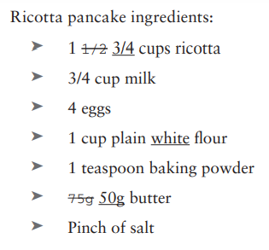

Q2. Mark up the following sentence with the relevant presentational elements.

The 1st time the **bold** man wrote in **italics**, he **emphasized** several key words.

Q3. Navigation Example as below

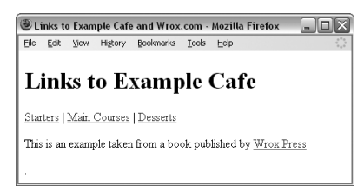

Q4. Images and alignment

Q5. Table Exercise

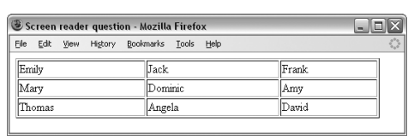

Q6. Create an e-mail feedback form that looks like the one shown.

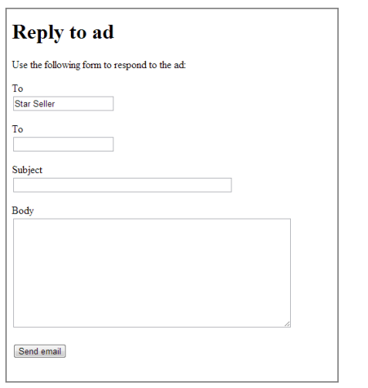

Q7. Create a voting or ranking form that looks like the one shown in Figure.

